Operation costs

Input: sum∈N，length∈N，on[1...length] ∈Nlength  ,off[1...length] ∈Nlength

pays∈N，coststops∈N，

Output: count∈N

Precondition:1≤length≤1000;0<pays≤100;1≤coststops≤100000

$∀[i]$ ( 1≤length≤1000):0≤on[i] ≤800,0≤off[i] ≤800

Postcondition:

Count:=

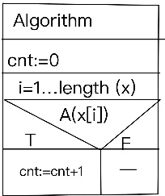

Code:

using System;

namespace B3

{

internal class Program

{

static void Main(string[] args)

{

int count = 0;

int sum = 0;

int length = int.Parse(Console.ReadLine());

string all = Console.ReadLine();

int pays = Convert.ToInt32(all.Split(' ')[0]);

int coststops = Convert.ToInt32(all.Split(' ')[1]);

int[] on=new int[length];

int[] off=new int[length];

for (int i = 0; i < length; i++)

{

string input = Console.ReadLine();

on[i] = Convert.ToInt32(input.Split(' ')[0]);

off[i] = Convert.ToInt32(input.Split(' ')[1]);

sum = on[i] \* pays + sum; }

if (sum > (coststops \* length))

{

count++;

Console.WriteLine(count);

}

else

{

Console.WriteLine(count);

}

Console.ReadKey();

}

}

}